Embedding a video in your post discussion post.

For this discussion, one of the requirements will be to embed a video in your discussion post to share with the students.
Please follow these steps to embed a video:
- Hit “REPLY” just like you would to create a new post.
- From the Rich-text editor box select: the stack of books (“public resources”)
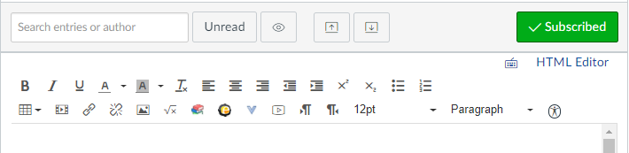

- Search the public resource options to locate your video (hint: If you found your video on Youtube, Vimeo, etc, copy the URL from there click the public resource you want to use, and paste the URL in the search box.
- When the video options pop up, select the BLUE embed button
- The video will appear in your post.

Alternate Method:
If the video you selected is NOT from a Public Resource but you do have an EMBED code:
- Go to the Rich Text Editor
- Select the movie strip icon (“insert/edit media)

- Click the “Embed” tab.
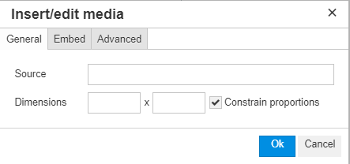
- Paste in your embed code
- Click OKAY.
Your video will now appear

